Ex:no:3
Date:15\3\25
3.Write a servlet program that prints “Hello, World!” when accessed through a browser.
Aim:
To Write a servlet program that prints “Hello, World!” when accessed through a browser using java.
Program:
Helloworld.java:
package com.muthulakshmi.servlet;

import java.io.IOException;
import java.io.PrintWriter;

import javax.servlet.ServletException;
import javax.servlet.annotation.WebServlet;
import javax.servlet.http.HttpServlet;
import javax.servlet.http.HttpServletRequest;
import javax.servlet.http.HttpServletResponse;

/**
* Servlet implementation class Helloworld
*/
@WebServlet("/Helloworld")
public class Helloworld extends HttpServlet {
private static final long serialVersionUID = 1L;

/**
* @see HttpServlet#HttpServlet()
*/
public Helloworld() {
super();
// TODO Auto-generated constructor stub
}

/**
* @see HttpServlet#doGet(HttpServletRequest request, HttpServletResponse response)
*/
protected void doGet(HttpServletRequest request, HttpServletResponse response) throws ServletException, IOException {
PrintWriter p=response.getWriter();
p.println("hello world");
}

/**
* @see HttpServlet#doPost(HttpServletRequest request, HttpServletResponse response)
*/
protected void doPost(HttpServletRequest request, HttpServletResponse response) throws ServletException, IOException {
// TODO Auto-generated method stub
doGet(request, response);
}

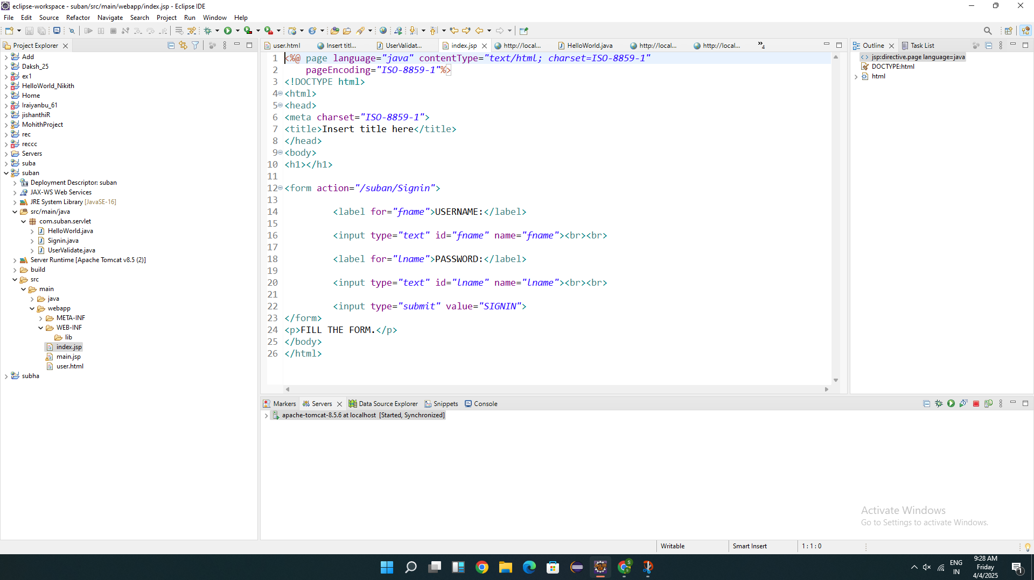

OUTPUT:
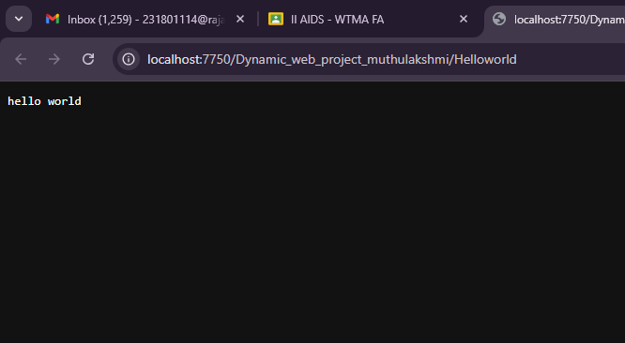

Result:
Thus the servlet hello world program was executed successfully on web browser.

